A.1 # Table and Database creation
CREATE DATABASE CollegeDB;
USE CollegeDB;
CREATE TABLE Course (
CourseID INT PRIMARY KEY,
CourseName VARCHAR(50) NOT NULL,
Fees DECIMAL(10,2) NOT NULL
);
CREATE TABLE StudentResult (
StudentID INT PRIMARY KEY,
StudentName VARCHAR(50) NOT NULL,
CourseID INT,
City VARCHAR(30),
Marks INT,
FOREIGN KEY (CourseID) REFERENCES Course(CourseID)
);
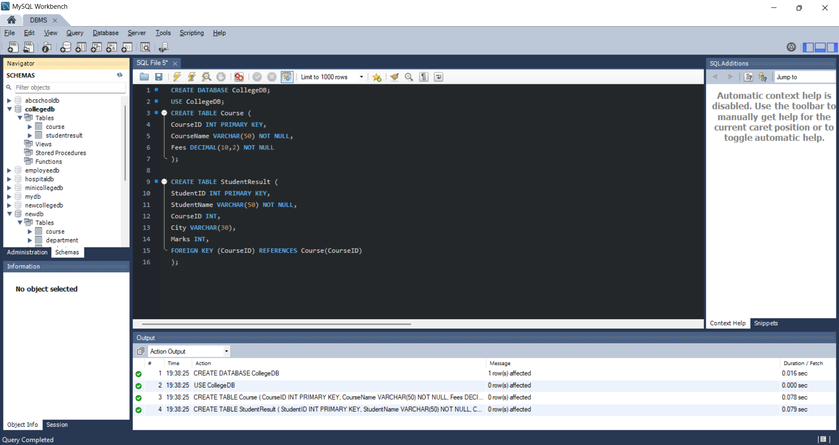

# Data insertion
INSERT INTO Course (CourseID, CourseName, Fees)
VALUES
(101, 'BSc IT', 45000.00),
(102, 'BCA', 40000.00),
(103, 'BSc CS', 42000.00),
(104, 'Data Science', 55000.00);
INSERT INTO StudentResult
(StudentID, StudentName, CourseID, City, Marks)
VALUES
(1, 'Rahul Sharma', 101, 'Mumbai', 78),
(2, 'Priya Patil', 102, 'Pune', 85),
(3, 'Aman Verma', 103, 'Nashik', 67),
(4, 'Sneha Joshi', 101, 'Mumbai', 91),
(5, 'Karan Mehta', 102, 'Thane', 74),
(6, 'Neha Shah', 101, 'Pune', 88),
(7, 'Rohan Desai', 103, 'Mumbai', 69),
(8, 'Meera Kulkarni', 102, 'Nashik', 82),
(9, 'Arjun Nair', 101, 'Thane', 59),
(10, 'Divya More', 102, 'Mumbai', 93);
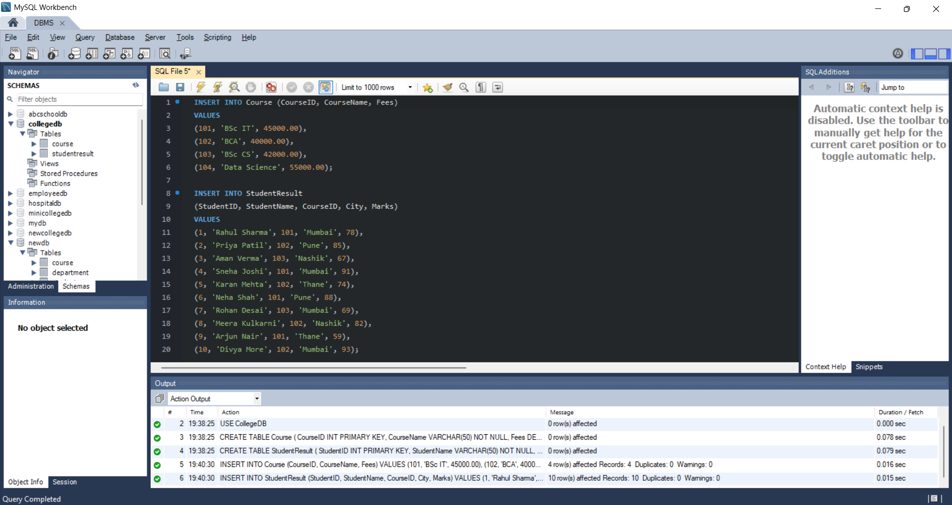

A.2
SELECT StudentName, Marks
FROM StudentResult
WHERE Marks > (
SELECT AVG(Marks)
FROM StudentResult
);
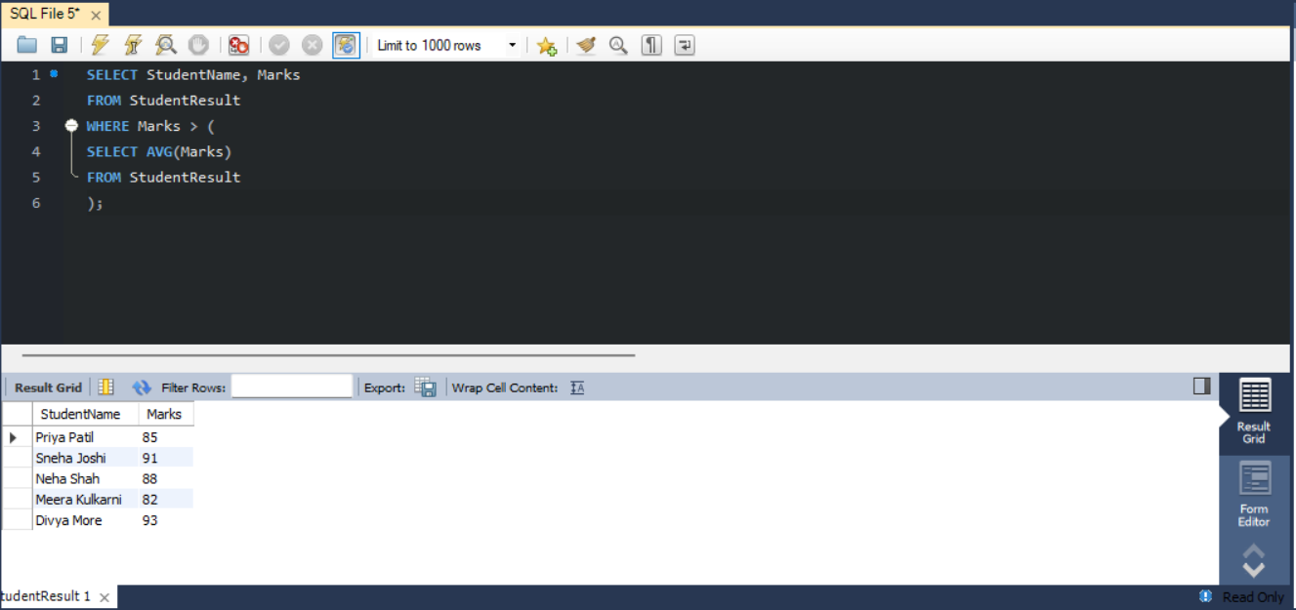

A.3
SELECT StudentID, StudentName, CourseID, Marks
FROM StudentResult
WHERE CourseID = (
SELECT CourseID
FROM Course
WHERE CourseName = 'BCA'
);
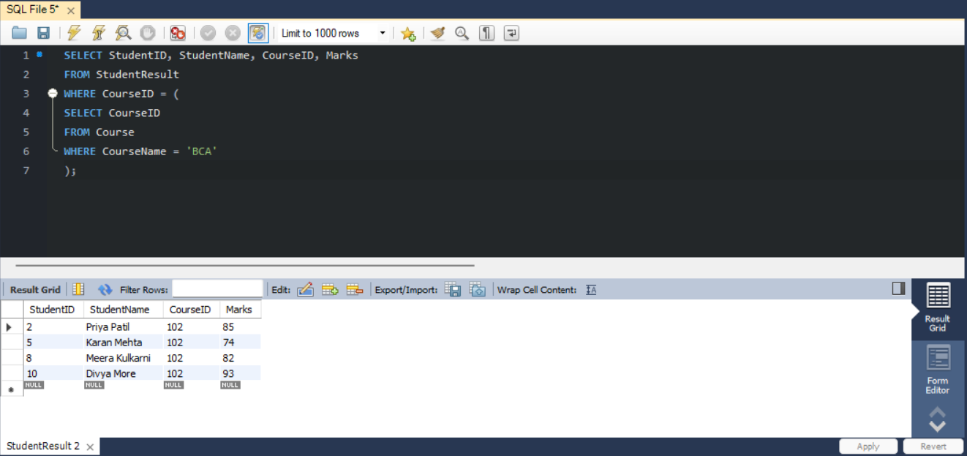

A.4
SELECT
StudentName,
Marks,
(SELECT AVG(Marks) FROM StudentResult) AS AverageMarks
FROM StudentResult;
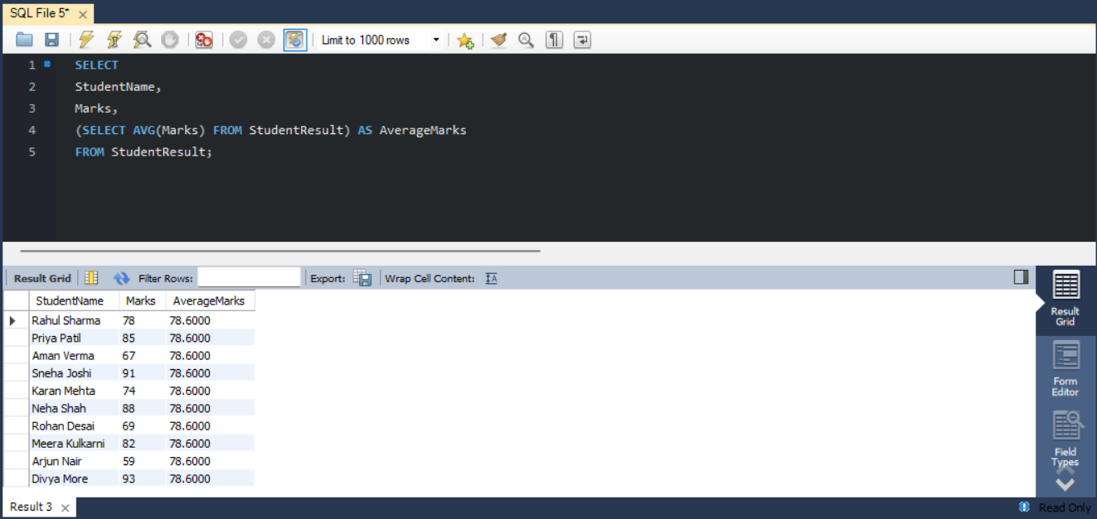

A.5
SELECT StudentID, StudentName, CourseID, Marks
FROM StudentResult S1
WHERE Marks > (
SELECT AVG(Marks)
FROM StudentResult S2
WHERE S2.CourseID = S1.CourseID
);
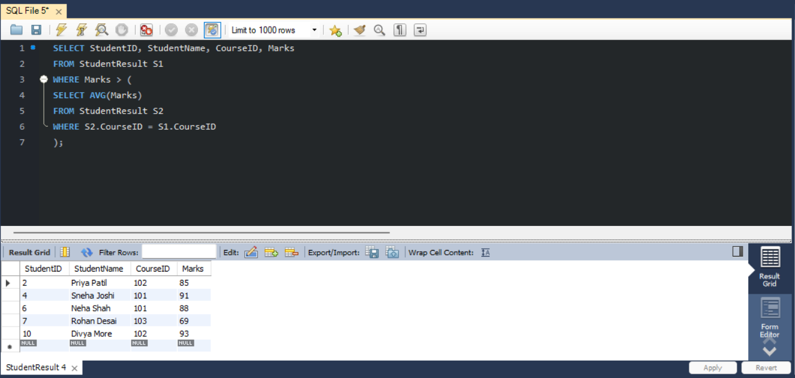

A.6
# Using EXISTS
SELECT CourseID, CourseName
FROM Course C
WHERE EXISTS (
SELECT 1
FROM StudentResult S
WHERE S.CourseID = C.CourseID
);
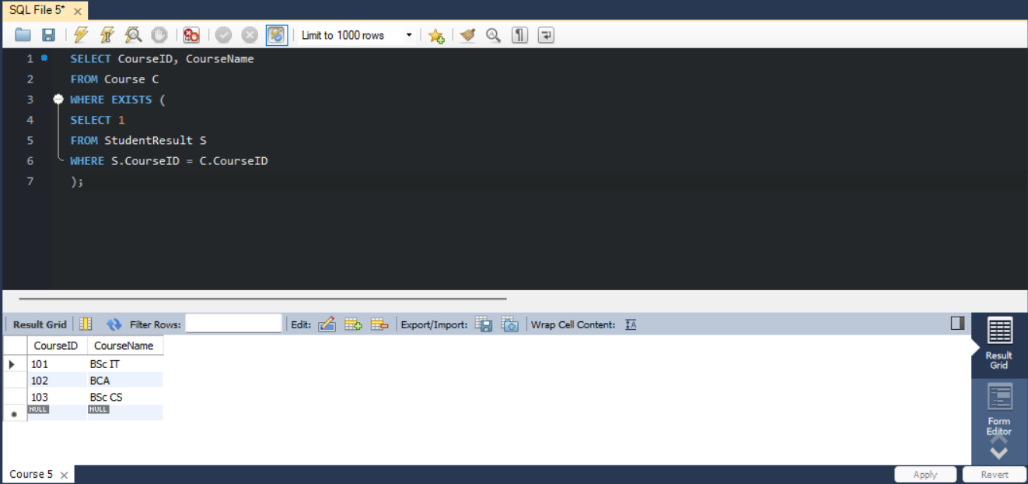
# using NOT EXISTS
SELECT CourseID, CourseName
FROM Course C
WHERE NOT EXISTS (
SELECT 1
FROM StudentResult S
WHERE S.CourseID = C.CourseID
);
